Carbonate dissolution and ultrastructural breakdown in planktonic foraminifera in The Sea of Okhotsk
Alexandra Romanova, Far East Geological Institute FEB RAS, sandra_ru@bk.ru
Vladimir Anin, Pacific Oceanological Institute FEB RAS, annin@poi.dvo.ru
Sergey Pletnev, Pacific Oceanological Institute FEB RAS, pletnev@poi.dvo.ru
Tatyana Tarasova, Institute of Marine Biology FEB RAS, tanya.taras2012@yandex.ru

80 sediment stations collected along the meridian transect across the Sea of Okhotsk were studied in order to reveal patterns of dissolution based on planktonic foraminifera. The degree of calcite dissolution intensity from planktonic foraminifera determined by different indices (degree of fragmentation, presence of susceptible to dissolution species, benthos/ plankton ratio). The highest degree of dissolution evidenced by a large number of shell fragments and corroding walls were found in sediments from the area of the Kuril Islands. The most revealing measure of probable dissolution of foraminiferal shells in the central part of the sea is a low number and lack of thin-walled species. The effects of dissolution on foraminiferal shells were studied for dominated species Neogloboquadrina pachyderma sin and Globigerina bulloides using a scanning electron microscope. The results are important for understanding processes of sedimentation, the paleo-oceanologial reconstructions and for obtaining reliable results in isotope analyzes.
Key words: foraminifera, assemblages, carbonate dissolution, sedimentation, the Sea of Okhotsk.
I. Introduction
Preservation of foraminifera shells is one of the proxy for bottom water chemistry and also indirectly for deep circulation and carbon cycling, especially in areas where planktonic foraminifera (PF) play an important role in sedimentation [1]. The contribution of foraminifera to the sediment formation in the Sea of Okhotsk is not so noticeable as compared with Diatoms and Radiolaria. However, if we consider the importance of PF as source of biogenic carbonates in the sediments at the Sea of Okhotsk, their role is very significant [2]. Sediment trap data obtained by coccolithophore –CaCO3 flux collected only in one station in the central part of the sea indicates that carbonate dissolution in that area is already taking place at shallow depth [3]. A quantitative and qualitative evaluation of the foraminifera dissolution degree has not been determined yet.
Typically, the authors observed visually fragments and corroded shells in sediments collected from different parts of the sea [4,5,6]. As a result, the patterns of PF dissolution in the Sea of Okhotsk are still poorly studied.
II. Hydrographic setting
As a source region of North Pacific Intermediate Water, the Sea of Okhotsk plays a significant role in the ventilation of the North Pacific [7]. The circulation in the Sea of Okhotsk is presented by a cyclonic gyre (Fig. 1.) consisting of the West Kamchatka Current (WKC) and the East Sakhalin Current (ESC) [8]. WKC originating from North Pacific water is a warm current and it keeps the southern part of Kamchatka coast ice-free.
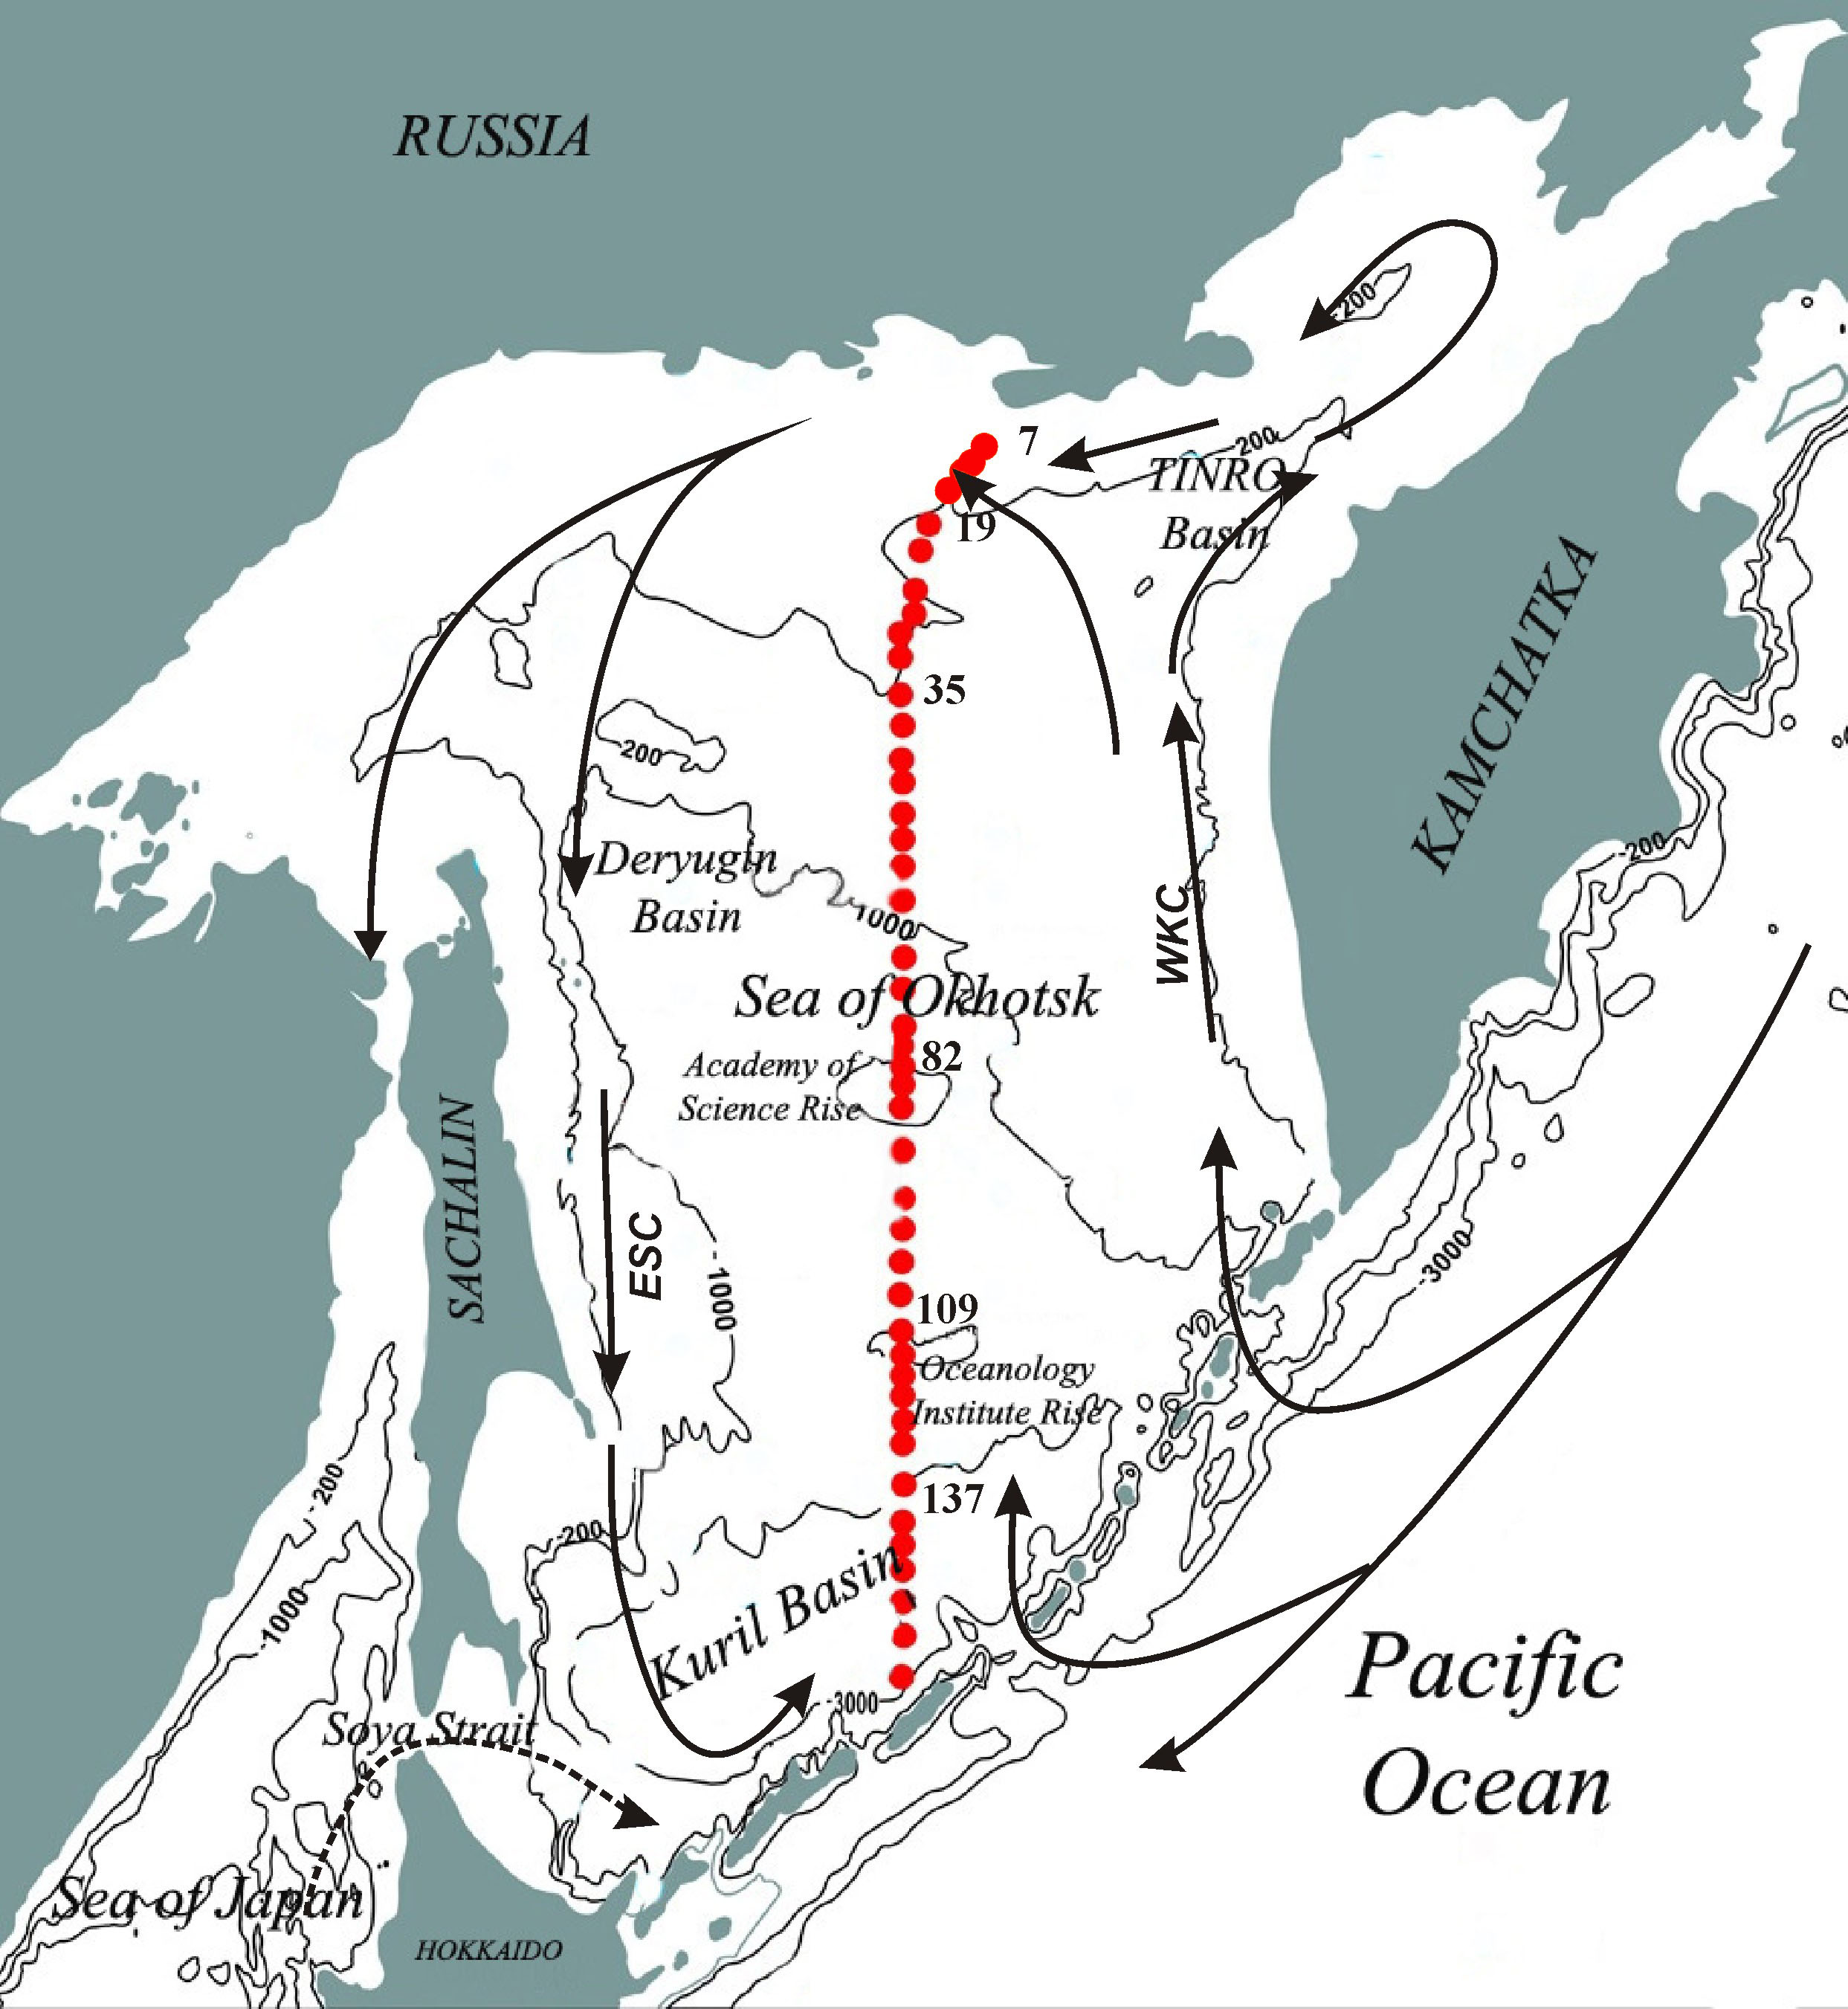
Fig. 1. Bathymetry with location of the studied sediment stations and currant trajectories of the East Sakhalin Current (ESC), West Kamchatka Currant (WKC) and Soya Currant (dash line).
The ESC flows southward off the east coast of Sakhalin Island and is influenced by the discharge from the Amur River. From June to November warm, salty water of the Soya Current enters from the Sea of Japan (Fig. 1). Sea ice is brought by both the East Sakhalin Current and the northerly wind in winter, which makes this region’s sea to be covered by ice in spite of low latitude. The oxygen minimum zone in the Sea of Okhotsk is about at 750-1500 m water depth [9]. The sea is surrounded by Kamchatka Peninsula, Eurasian continent, and Sakhalin Island. The chemical composition of the seawater is greatly affected by the coastal and river runoff. The shelf occupies about 40% of its surface area.
III. MATERIAL AND METHODS
80 sediment stations of the transect “Magadan –South Kuril” were collected by piston corer (upper depth? 0-5 cm) during the Academician Lavrentev 42 cruise (Figure 1) at water depth from 107 to 3369 m. Samples were prepared by standard techniques of foraminiferal analysis. Dried sediment was washed and sieved through sieve with meshes of 63 μm. The samples were washed through under a weak spray of water to protect them from additional fragmentation. PF were identified using taxonomical classification of Loeblich and Tappan [10]. There are different micropaleontological methods considered to be linked to carbonate dissolution and preservation but their variations may partly be controlled by ecological or other factors. Thus mostly, a comprehensive approach was used in this carbonate dissolution-study. The whole >63 μm fraction was quantitatively analyzed through stereoscopic microscope to determine the fragmentation index, the presence of thin-walled species, benthos to plankton ratio. Fragment is defined as a test portion, less than two-thirds of its original size [11]. The fragmentation index (Frag) for each sample was calculated according to the following equation [12]:
Frag = Nfr* 100%/ Ntotal ,
Where Nfr is a number of fragments and Ntotal – absolute abundance of foraminifera. Frag was calculated for the samples contained number of shells sufficient for statistics (300 shells). Deep-sea benthic foraminifera have normally thick and smooth shells that are more resistant to dissolution than those of planktonic foraminifera and the ratio between whole shells of the two groups (the BF/BF+PF) decreases with increasing dissolution [12]. Presence of corrosion traces and character of dissolution were studied in detail using a scanning electron microscope (SEM).
IV. RESULTS
According to Berger [13], benthic foraminifera are approximately three times less susceptible to dissolution than planktonic foraminifera, but more susceptible than nannofossils. Therefore, enhancing of carbonate dissolution will result in increase of BF/BF+PF, decrease of the PF abundance, and then increase of the planktonic fragment ratio. The picture is more complicated in the Sea of Okhotsk due to different sedimentation patterns, mixing of water masses and local sea bottom effects (Table 1).
Table 1. Total abundance of PF, fragmentation index, ratio of Bf/Bf+Pf, presence of susceptible to dissolution species corresponded to different depositional environments.
Region | Stations | Water depth, m | Sediments | Total abundance, ind/g of dry sediments | Max Frag, % | Bf/Bf+Pf | Thin-walled species
Coastal | 7-19 | 100-170 | sandy silt | 0-0,1 | 0 | 1 | -
Northern | 19-31 | 180-240 | aleurite-clayey silt | 0-30 | 0 | 0-0,6 | -
Central | 35-132 | 180-1580 | fine-aleurite clay | 0-449 | 5 | 0,03-1 | +
The Academy of Science Rise | 82-87 | 940-1020 | fine-aleurite clay | 105-910 | 10 | 0,007-0,04 | +
The Oceanology Institute Rise | 109-118 | 967-1130 | fine-aleurite clay | 946-3116 | 13 | 0,01-0,05 | +
Kuril Basin | 137-162 | 2790-3538 | fine-aleurite clay | 0-164 | 50 | 0,003-1 | +

In our case relatively high values of BF/BF+PF ratio are observed in coastal region and Kuril Basin (up to 1) due to absence or low content of PF. BF/BF+PF ratio demonstrates low values in central part of the sea (0,03 -1). There are no significant changes compared with values for another region of the sea. Basically this dissolution proxy is more indicative in abyssal sediments because in shallower settings, the BF/BF+PF ratio is primarily controlled by food availability [12].
Species of PF living in the Sea of Okhotsk depending on the degree of resistance to the dissolution can rank in order of decreasing: N. pachyderma, G. bulloides, G. quinqueloba, G. scitula, G. glutinata, G. uvula. PF are absent in the northern continental shelf and slope and only single shells of N. pachyderma and G. bulloides are presented (0.1 ind/g of dry sediments). There are no thin-walled species in stations from 1 to 31. Such distribution of PF species is controlled mostly by ecological preferences. Due to high sedimentation rates, and, most likely, the low productivity of foraminifera in the northern part of the sea in comparison to the other sea areas, concentration of the shells in the sediment are the smallest. It was established [14 ] that shallow depths of these areas characterized by low aggressivity of these waters to calcium carbonate (water saturation degree by calcite > 80% in the waters of the Sakhalin and Kamchatka slopes and >100% in Sakhalin Bay). As a result, traces of PF dissolution are not established in this area.
Central part of the Sea of Okhotsk is characterized by relatively shallow water depths and by patchy PF distribution (stations from 33 to 132). Absolute abundance of PF in the sediments increases from the north to the central part of the sea near the Institute of Oceanology Rise and decreased gradually to the Kuril Islands [15]. Peak concentration of foraminifera in the sediments is observed in the Oceanology Institute Rise where the total foraminiferal abundance rises to 3538 ind/g of dry sediments. There are no PF at the stations 34-42, 46-48. Low concentration of PF in the sediments was found at stations 33, 43, 49-54, 60. Shells of PF at these stations are well preserved. Beside N. pachyderma sin and G. bulloides G. quinquiloba are presented in the sediments at stations 33, 66, 73, 74. There are no fragments or any visible traces of corrosion on PF shells at these stations. Only several shells of corroded N. pachyderma sin. were found in the sediments of stations 54, 65. From the station 66 PF assemblages are presented by N. pachyderma, G. bulloides, G. quinqueloba, G. scitula, G. glutinata, G. uvula. There are no thin-walled species beside decreased PF absolute abundance at stations 72, 75, 83, 86, 100, 120. We can assume that thin-walled species in the sediments might be traces of no-dissolution effect while the presence of only more resistant N. pachyderma gives the basis for more detailed analysis.
There is a high degree of dissolution, as evidenced by a large number of fragments of shells and corroding walls near the Kuril Islands. At one of the studied station (150) resistant to dissolution species N. pachyderma sin. is dominated and there are no thin- walled specimens (100%). Shells were found corroded or even broken at the sediment stations 157 presented a large number of fragments (up to 50%). At the same time, in other studied samples taken near Kuril basin (147, 154) G. glutinata and G. uvula are presented, which indicate the absence or minimal dissolution effect. K. Kurihara [16] also found that there are thin-walled species in some samples, in others - only one species N. pachyderma sin in the Kuril Basin. The dissolution of planktonic foraminifera shells in the area of the Kuril Basin was pointed out by other authors [4, 5]. We can assume the existence of lysocline in Kuril Basin. The lysocline is by definition the depth at which sedimentary calcium carbonate dissolution is first observed to occur, with a drop in the calcite content of the sediments to values below 90% taken as the first evidence of dissolution [17]. The depth of the lysocline in the Pacific Ocean is 3000- 3500m [17]. Carbonate compensation depth in the Sea of Japan is abnormally high compared to the Pacific Ocean and the Sea of Okhotsk lying at a depth of 1800-2000 m [9]. The main difference from the Okhotsk Sea of Japan is the presence of a wide continental shelf and a large influx of fresh water of the Amur River, which have a great influence on oceanographic processes and bring the body of water to the basins of the subarctic type.
Increasing carbonate dissolution was determined in the Sea of Okhotsk by coccoliths, expressing flux reduction of 82%, and in the increasing percentage of etched coccoliths of Coccolithus pelagicus from 32 to 90% from 258 to 1061 m water depth [3]. Unfortunately, we have no foraminiferal data from sediment trap to compare the data at different depths. We only have the results from sediment trap at 258m water depth [18]. We compared sediment trap data with the results from the adjacent sediment station [15]. The relative abundance of the species is almost the same. There were no remarkable traces of corrosion and we recorded thin-walled species G. glutinata in the sediments. We can only speculate about the possible reasons of such results. During settling and sedimentation, individual coccoliths and coccospheres are highly susceptible to dissolution processes due to their minute size and very low sinking rates. Lack of sinking vehicles makes coccoliths more susceptible to dissolution.
It has become obvious that dissolution of foraminifera tests in the water column is relatively insignificant and that most dissolution occurs at the sediment–water interface [19]. It was found that normalized potential alkalinity and Ca values in the near bottom waters of the Sea of Okhosk deep-water areas are considerably higher than those in the surface layer [14]. The sea is characterized by a high content of organic matter (mostly diatoms) in sediments, which respectively provides high CO₂ concentrations in bottom waters. In turn, this leads to the formation of significant concentrations of carbonic acid in pore waters and as a consequence the dissolution is enhanced at the sediment- water interface [20].
The Sea of Okhotsk, a semi-isolated swimming pool located within the active continental zone of transition from the mainland to the ocean, has anomalous methane concentration and heavy hydrocarbons in the bottom water, which are common in almost all sea areas. Gas hydrates are not a factor of enhanced foraminifera dissolution, the probable factor is the environment, which is formed in the places of their release. It is known that these environmental form, so-called, taphonomically-active zone, is characterized by anoxic conditions and the increased activity of biogeochemical processes. This leads to the destruction of biogenic carbonates. It was found that under anoxic conditions in the area of Deriugin depression not only planktonic but also benthic foraminifera are extremely low [6]. Apparently, similar processes may occur in other parts of the Sea of Okhotsk.
It was found that it is very problematic to use a uniform methodology for different areas to reveal universal traces of dissolution by PF. This is due, above all, to a variety of water conditions, sediments and sources contributing to sedimentation. There is a high degree of dissolution, as evidenced by a large number of fragments of shells and corroding walls in the Kuril Basin. In the central part of the sea the most revealing measure of probable dissolution of foraminiferal shells is a small abundance of PF and lack of thin-walled species. All these criteria must be considered in the analysis of the core data.
The preservation of planktonic foraminifera intensively depends on the internal wall structure, which consists of small, anhedral crystals on the proximal side, larger crystals toward the distal side, large crystals, forming the calcite crust in case of deep-living species [20]. The shell of N. pachyderma sin. containing the largest crystals is the most resistant one (Fig.2 a).
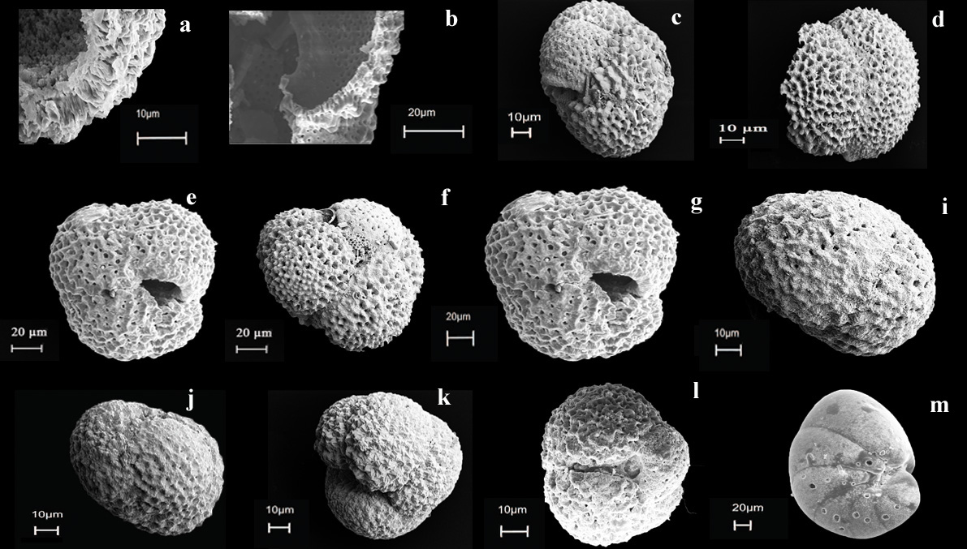
Fig. 2. Effect of dissolution on the test structure of N. pachyderma sin.(a, b, c, e, f, g, i, j, k, l), G. bulloides (d) and Nonionellina labradorica(m) and its appearance in SEM.

The samples that were selected for SEM study came mainly from the south-east region. Already while preparing them for study under a microscope there were problems with placing them on SEM tables. As can be seen above, the ultrastructure of N. pachyderma sin. worsens in regular patterns due to increasing carbonate dissolution (Fig. 2). Spine bases and ridges become denuded (Fig. 2 c, f, i), pores become bigger (Fig. 2 c, d, e, g) the surface becomes thinner (Fig. 2 b) until the thinnest parts will crack off. Shells were often different in fragility, up to extreme, and often broke due thin walls. Furrows on calcite growth are often marked in areas of corrosion (Fig. 2 b). Whereas the characteristic feature of well-preserved shells N. pachyderma sin. is the largest calcite growths (2 a). On corroded shells of N. pachyderma sin. from the south-eastern part of the sea growths practically "erased" up to the inner wall of the shell (Figure 2 b, c, f, i, j, k). Other researchers [20] found that in conditions of high dissolution shells destruction primarily begins with last chamber. This feature is identified and investigated by SEM (Fig. 2 f, l).
As shown by our foreign colleagues’ study [21] the dissolution processes significantly influence the isotopic composition of foraminiferal shells, which can lead to errors in isotope analysis (oxygen, carbon, the ratio of Mg / Ca), made by foraminifera. Investigations on the shell calcite show that the ratio of elements such as Na, Mg, Sr, F, V, U versus Ca decrease in the course of dissolution in some planktonic foraminiferal species. The reason is that chambers, keel and "cortex", are each secreted in different depths displaying a distinct chemical water composition, and dissolution removes the most "impure" calcite parts first and faster than pure calcite [21]. For more reliable results in the selection of shells for the isotopic analyzes it is necessary to use whole shells, which are not corroded.
V. Acknowledgements
The authors would like to express their sincere appreciation to Dr. A. Derkachev for provided materials. Research supported by a grant from the FEB RAS 15-I-2-063.
REFERENCES
- Berger W. H ., Parker F.L. Diversity of planktonic foraminifera in deep-sea sediments // Science. 1970. V. 168. pp. 1345 – 1347.
- Saidova, K.M. Ecology of Foraminifera and Paleogeography of the USSR Far Eastern Seas and the Northwestern Pacific (Ekologiya Foraminiferi Paleogeographiya Dalnevostochnih Morei SSSR i Severo-Zapadnoi Chasti Tihogo Okeana). Nauka, Moscow. 1961.-pp.221. (In Russian)
- Broerse, A. T. C., P. Ziveri and S. Honjo: Coccolithophore (-CaCO3) flux in the Sea of Okhotsk: seasonality, settling and alteration processes //Mar. Micropaleontol. 2000, V.39, pp.179–200.
- Chekhovskaya, Maria P; Basov, Ivan A: Planktonic foraminifers from sediments of the southeastern Okhotsk Sea (the last 20000 years)// Stratigrafiya. Geologicheskaya Korrelyatsiya (Stratigraphy. Geological Correlation), 1997(2), pp.90-101.
- Belyaeva N. V., Burmistrova I. I., Planktonic foraminifera at the sediments in the Sea of Okhotsk // Oceanology. 2003. V.43. №2. pp. 219-227.
- Khusid T.A., Belyaeva N.V., Chehovskaya M. P., Matul A.G., Foraminifers in Late Pleistocene-Holocene Sediments of the Deryugin Basin of the Sea of Okhotsk // Oceanology. 2009. V. 49, № 5. pp. 762-771.
- Talley, L. D. An Okhotsk Sea water anomaly: implications for ventilation in the North Pacific // Deep-Sea Res. 1991. V. 38, pp.171–190
- Talley, L.D. and Nagata, Y. (eds.). The Okhotsk Sea and Oyashio region. PICES Sci. Rep., 1995. No. 2. 227 pp
- Bogdanov, K.T., Moroz, V.V. The Kuril – Kamchatka Current and Oyashio Current Water. Dalnauka, Vladivostok. 2004. 141 pp. (in Russian).
- Loeblich, A. R. and Tappan, H. Foraminiferal Genera and their Classification. Van Nostrand Rienhold Co., New York. 1987
- Berger, W.H., M.-C. Bonneau, and F.L. Parker, Foraminifera on the deep-sea floor: Lysocline and dissolution rate// Oceanolog. Acta. 1982. V.5, 2, 249-258,.
- Proxies in Late Cenozoic paleoceanography. Dev. In Mar. Geol. Ser. Edited by C. Hillaire Marcel and A. de Vernal. Elsevier, Amsterdam. 2009. V. 1. P. 213–262. doi:10.1016/S1572-5480(07)01011-1.
- Berger W.H. Paleoceanography: the deep-sea record, in the sea, edited by C. Emiliani, Wiley-Interscience, New York. 1981. pp. 1437-1519.
- Pavlova, G.Y., Tishchenko, P.Y., Nedashkovskii, A.P. Distribution of alkalinity and dissolved calcium in the Sea of Okhotsk // Oceanologya 2008. 48 (1), pp. 23 – 32 (English Translation of Okeanologiya by Pleiades Publishing, Inc.).
- Romanova A.V. Planktonic foraminifera of surface sediments in the Sea of Okhotsk // Vestnik FEB RAS. 2014. №3. pp. 85-94.
- Kurihara K. Planktonic Foraminifera of piston cores from the Kuril Basin, the Sea of Okhotsk // St. Paul’s Rev. Science. 1982. V. 4, №3. P. 65–77.
- Broecker, W. S., T. H. Peng , Tracers in the Sea , Lamont-Doherty Earth Observatory, Palisades, N. Y. 1982
- Alderman S.E. Planktonic Foraminifera in the Sea of Okhotsk: Population and Stable Isotopic Analysis from a sediment Trap. M.I.T. / W.H.O.I. Masters Thesis. 1996. pp. 1–88.
- Honjo S. The northwestern Pacific Ocean, a crucial ocean region to understand global change: rationale for new international collaborative investigations. In: Tsunogai, S. // Biogeochemical Processes in the North Pacific. Japanese Marine Science Foundation. 1997.pp. 1–15.
- Bé, A. W. H., Morsem J. W., Harrison, S. M. Progressive dissolution and ultrastructural breakdown in planktonic foraminifera. Special Publication 13, Cushman Foundation for Foraminiferal Research. 1975. pp. 27–55.
- Brown S.J., Elderfield H. Variations in Mg/Ca and Sr/Ca ratios of planktonic foraminifera caused by postdepositional dissolution: evidence of shallow Mg- dependent dissolution // Paleoceanography.1996. V.11 pp. 543–551.

